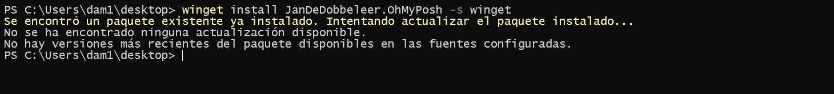
S

Crear carpeta en documents, WindowsPowerShell
~
notepad $PROFILE

oh-my-posh init pwsh --config "$env:POSH_THEMES_PATH\jandedobbeleer.omp.json"

set-ExecutionPolicy RemotedSigned

